**Project Title: Cooking made easy!**

**Team 25(DexLab)**

**Vishwa Shrirame | vshriram@iu.edu**

**Kumar Saurabh | ksaurabh@iu.edu**

**Raghav Chegu Shyam Kumar | racheg@iu.edu**

1. **Database Design**

**ER Diagram**

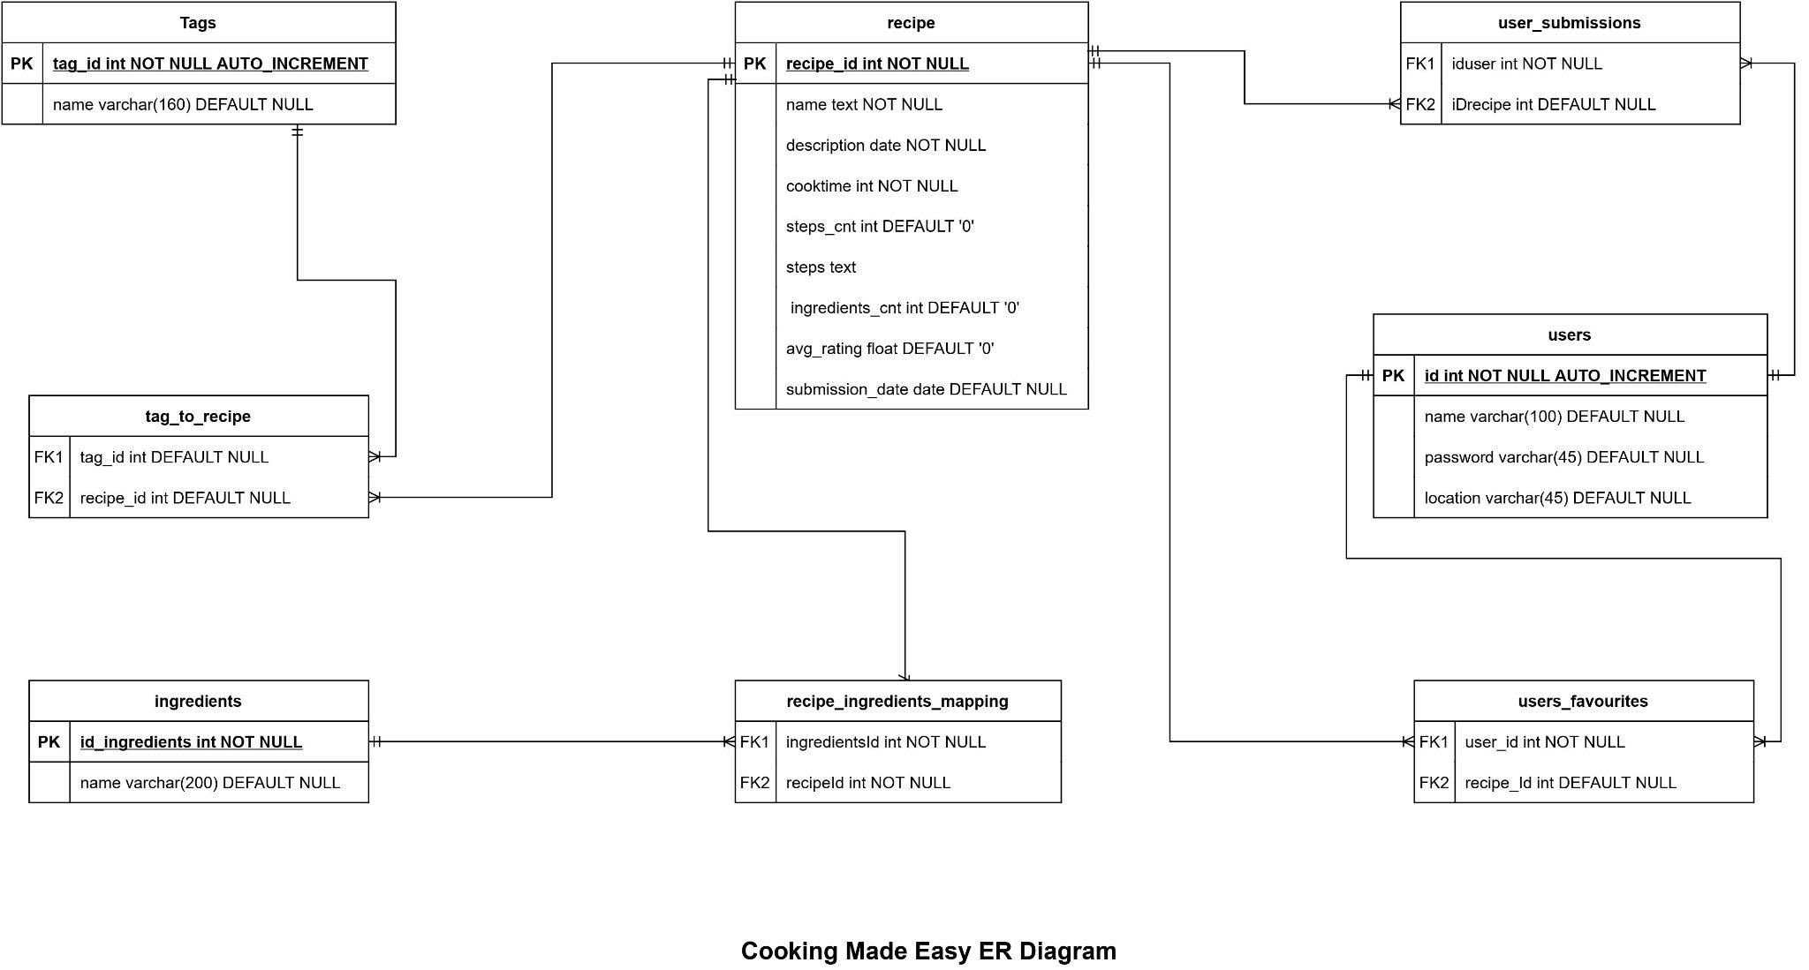

We have a total of 8 tables in our schema. They are as follows:-

Entities:

**recipe**

* The recipe table will have all the information of recipes
* Ease record will contain information such as recipe_id, name, description, number of steps, steps, ingredients count, average rating and submission date
* recipe_id will be the primary key

**ingredients**

* This table will contain all the unique ingredients in our database
* Each record will consist of ingredients_id, name
* Ingredients_id will be the primary key

**recipe_ingredients_mapping**

* This table will contain mapping between recipes and ingredients
* Each record will have recipe_id and ingredients_id as foreign key

**Tags**

* This table will contain all the unique tag related to recipes in our database
* Each record will consist of tag_id, name
* tag_id will be the primary key

**tag_to_recipe**

* This table will contain mapping between recipes and tags
* Each record will have recipe_id and tag_id as foreign key

**users**

* This table will contain all information of users.
* Each record will contain information such as user_id, name, name, location, password.
* user_id will be the primary key

**users_favourites**

* This table will contain mapping between users and their favourite recipes
* Each record will have recipe_Id and user_id as foreign key

**users_submissions**

* This table will contain mapping between users and their submission recipes
* Each record will have iDrecipe and iduser as foreign key

Relationship

**recipe and recipe_ingredients_mapping** – *Many: Many* relationship

**User and recipe_ingredients_mapping** – *Many: Many* relationship

**Tags and tag_to_recipe** – *Many: Many* relationship

**recipe and tag_to_recipe** – *Many: Many relationship*

**user and users_favourites** – *Many: Many relationship*

**recipe and users_favourites** – *Many: Many relationship*

**user and users_submissions** – *Many: Many relationship*

**recipe and users_submissions** – *Many: Many relationship*

So our ER Diagram explains the relationship between recipes and ingredients, recipes and tags, recipes and users. The users table is mapped to user favourites on a one-to-many relationship, whereas the recipes table is mapped to ingredients on one to one relationship.

1. **Describe Data types**

**recipes -**

|  |  |
| --- | --- |
| **Attribute** | **Data-type** |
| **recipe_id** | INT |
| **name** | TEXT |
| **description** | TEXT |
| **cooktime** | INT |
| **steps_cnt** | INT |
| **steps** | TEXT |
| **ingredients_cnt** | INT |
| **avg_rating** | FLOAT |
| **submission_date** | DATE |

**users -**

| **Attribute** | **Data-type** |
| --- | --- |
| **id** | INT |
| **name** | VARCHAR (100) |
| **password** | VARCHAR (45) |
| **location** | VARCHAR (45) |

**tags -**

|  |  |
| --- | --- |
| **Attribute** | **Data-type** |
| **tag_id** | INT |
| **name** | VARCHAR (160) |

**users_favourites -**

|  |  |
| --- | --- |
| **Attribute** | **Data-type** |
| **user_id** | INT |
| **recipe_id** | INT |

**ingredients -**

|  |  |
| --- | --- |
| **Attribute** | **Data-type** |
| **id_ingredients** | INT |
| **name** | VARCHAR (200) |

**user_submissions -**

|  |  |
| --- | --- |
| **Attribute** | **Data-type** |
| **iduser** | INT |
| **IDrecipe** | INT |

**tag_to_recipe -**

|  |  |
| --- | --- |
| **Attribute** | **Data-type** |
| **tag_id** | INT |
| **recipe_id** | INT |

**recipe_ingredients_mapping -**

|  |  |
| --- | --- |
| **Attribute** | **Data-type** |
| **ingredients_id** | INT |
| **recipe_id** | INT |

1. **Descirbe Constraints and Primary keys**

**Primary Keys**

|  |  |
| --- | --- |
| **PRIMARY KEY** | **Description and Table Name** |
| **recipe_id** | Unique ID of a recipe |
| **user_id** | Unique ID of a user |
| **tag_id** | Unique ID of a tag |
| **ingredients_id** | Unique ID of an ingredient |

1. **Code to create database**

**Create cooking_made_easy database:**

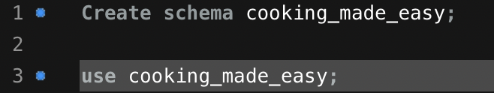

**Create recipe table:**

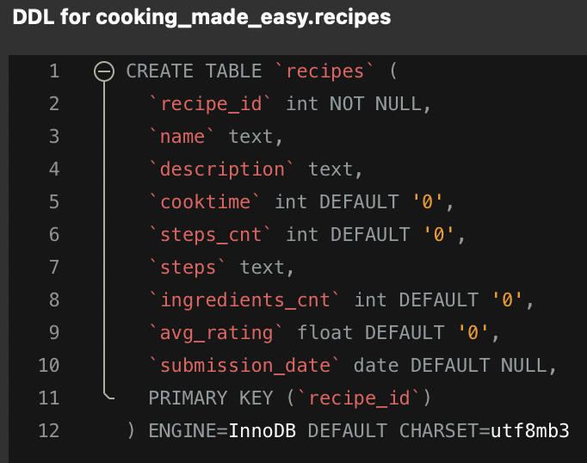

**Create Tags table:**

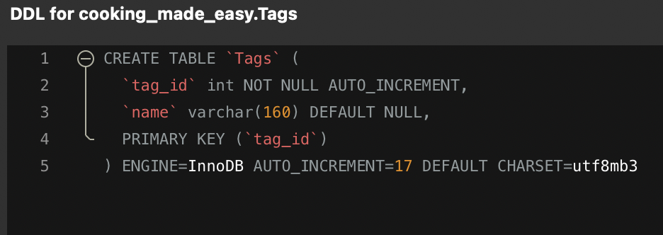

**Create ingredients table:**

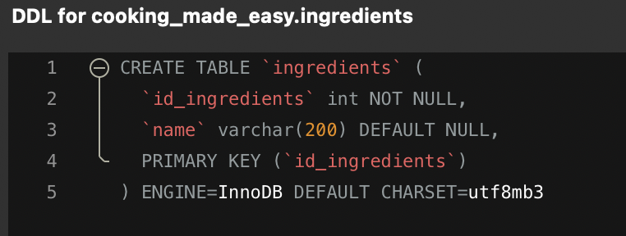

**Create users table:**

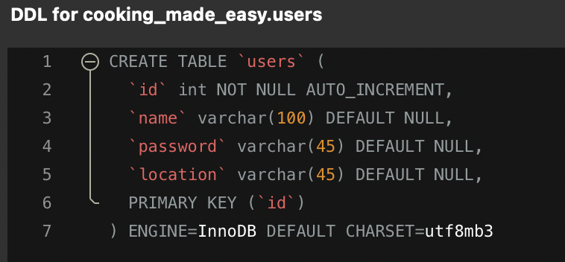

**Create tag_to_recipe table:**

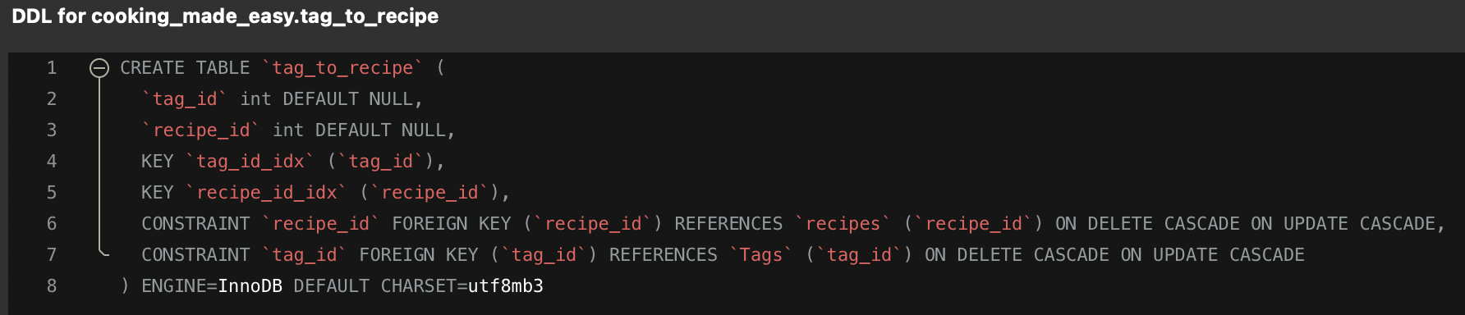

**Create user_favourite and user_submission tables:**

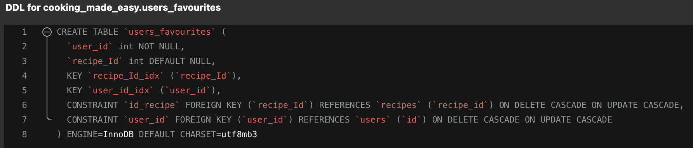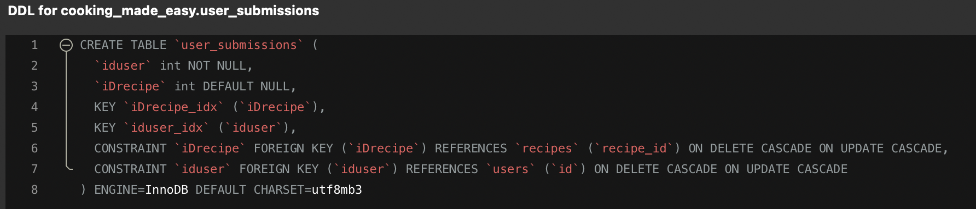

**For data insertion we have cleaned our data and have made changes in the python notebook and exported it in csv after that it was imported in the database using command line.**

1. **Loading data for processing:**

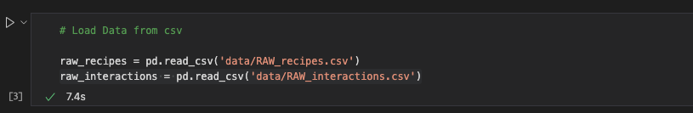

1. **Processing data and cleaning for csv formation for recipes table**

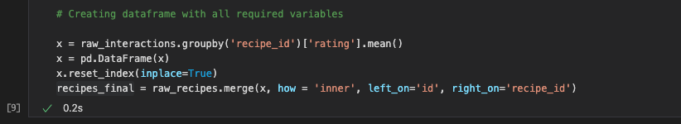

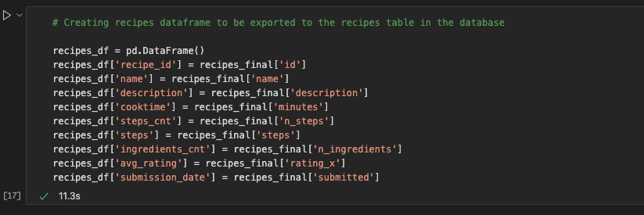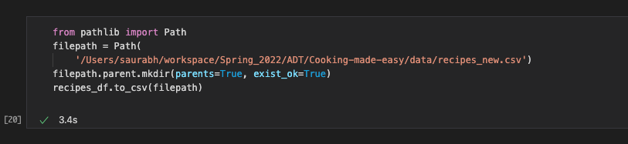

1. **Formatting data for Tags and tags_recipe_mapping table:**

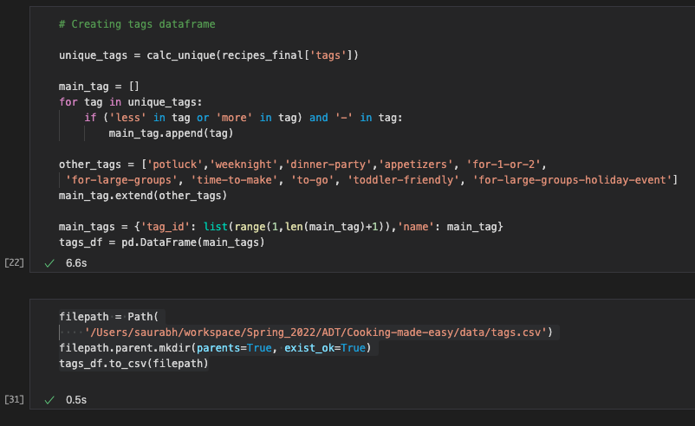

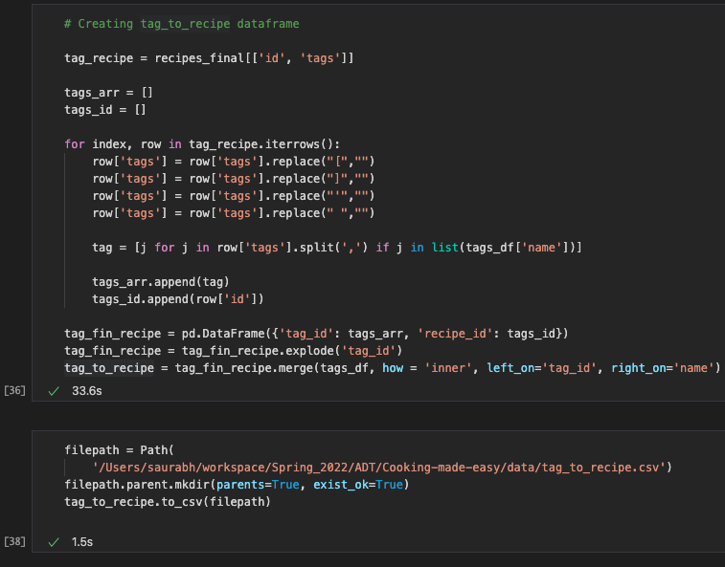

1. **Formatting the indregdients and recipe_ingredients_mapping tables:**

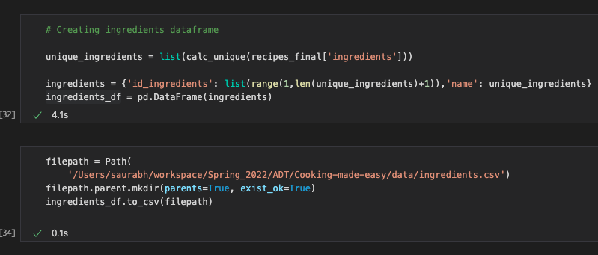

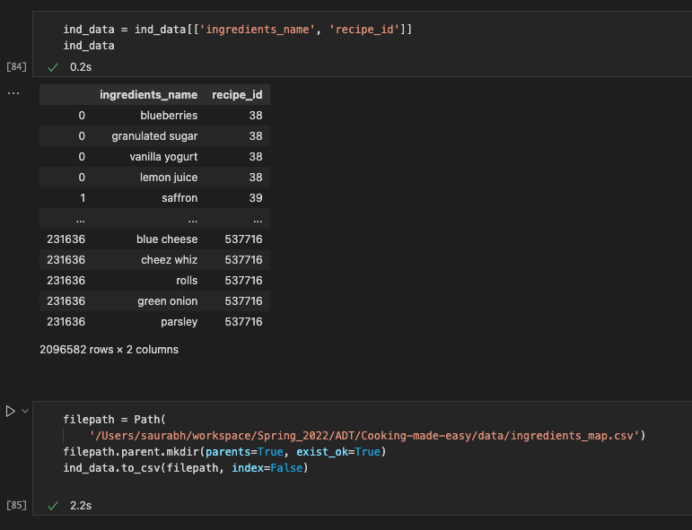

1. **Explain how data is imported**

**We have used MySQL CLI to import data from CSV file to the table in the readify database.**

**Set global local_infile to 1 to use load command for importing csv data to table**

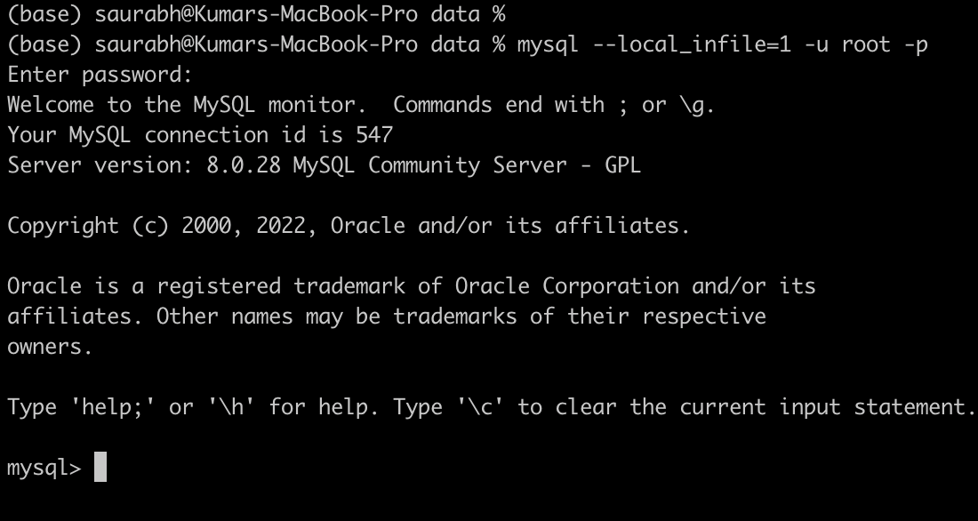

**Use load data local in file command to import data from csv file to the tables in the database**



**Data dictionary -**

**recipes -**

|  |  |  |  |  |  |
| --- | --- | --- | --- | --- | --- |
| **Table Name** | **Attribute** | **Description** | **Data_type** | **nullable** | **Example** |
| recipes | recipe_id | recipe ID - PRIMARY KEY | INT | N | 1 |
| recipes | name | recipe name | TEXT | Y | Briyani |
| recipes | description | User-provided description | TEXT | Y | Veg Briyani |
| recipes | cooktime | Minutes to prepare recipe | INT | Y | 30 |
| recipes | steps_cnt | Number of steps in recipe | INT | Y | 1 |
| recipes | steps | Text for recipe steps, in order | TEXT | Y | Cook in Handi |
| recipes | ingredients_cnt | Number of ingredients | INT | Y | 10 |
| recipes | avg_rating | Average rating for that recipe | FLOAT | Y | 4.3 |
| recipes | submission_date | Date recipe was submitted | DATE | Y | 2020-01-01 |

**users**

| **Table Name** | **Attribute** | **Description** | **Data_type** | **nullable** | **Example** |
| --- | --- | --- | --- | --- | --- |
| users | id | User id - PRIMARY KEY | INT | N | 1 |
| users | name | User name | VARCHAR(45) | Y | Samar Deep |
| users | password | User password | VARCHAR(45) | Y | gurudatta |
| users | location | User location | VARCHAR(45) | Y | Bloomington |

**tags -**

|  |  |  |  |  |  |
| --- | --- | --- | --- | --- | --- |
| **Table Name** | **Attribute** | **Description** | **Data_type** | **nullable** | **Example** |
| tags | tag_id | Tag id - PRIMARY KEY | INT | N | 1 |
| tags | name | Tag name | VARCHAR(160) | N | Under 30 min |

**users_favourites -**

|  |  |  |  |  |  |
| --- | --- | --- | --- | --- | --- |
| **Table Name** | **Attribute** | **Description** | **Data_type** | **nullable** | **Example** |
| users_favourites | user_id | User id - PRIMARY KEY | INT | N | 1 |
| users_favourites | recipe_id | Recipe id | INT | Y | 2 |

**ingredients -**

|  |  |  |  |  |  |
| --- | --- | --- | --- | --- | --- |
| **Table Name** | **Attribute** | **Description** | **Data_type** | **nullable** | **Example** |
| ingredients | id_ingredients | Ingredient id - PRIMARY KEY | INT | N | 1 |
| ingredients | name | Ingredient name | VARCHAR(200) | Y | Milk |

**user_submissions -**

|  |  |  |  |  |  |
| --- | --- | --- | --- | --- | --- |
| **Table Name** | **Attribute** | **Description** | **Data_type** | **nullable** | **Example** |
| user_submissions | iduser | User id - PRIMARY KEY | INT | N | 100 |
| user_submissions | IDrecipe | Recipe id | INT | Y | 32 |

**tag_to_recipe -**

|  |  |  |  |  |  |
| --- | --- | --- | --- | --- | --- |
| **Table Name** | **Attribute** | **Description** | **Data_type** | **nullable** | **Example** |
| tag_to_recipe | tag_id | Tag id - PRIMARY KEY | INT | Y | 45 |
| tag_to_recipe | recipe_id | Recipe id | INT | Y | 29 |